
ОБЩЕСТВО С ОГРАНИЧЕННОЙ ОТВЕТСТВЕННОСТЬЮ
«ЛАЗЕРТАГ»

ПАСПОРТ

Смоленск
LIMITED LIABILITY COMPANY
LASERWAR

SPIDER
charger
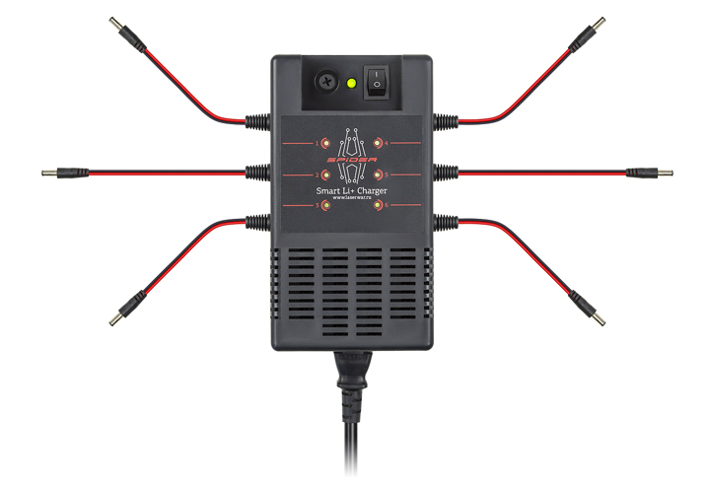

SPECIFICATION

Dear customer!
Our company welcomes and thanks you for the decision to buy our products, and is confident that the purchased device will bring you a long-term pleasure. The warranty certificate establishes the guarantee of the product in the amount provided for by the Law on consumer protection of the Russian Federation.
This warranty certificate is valid for 6 months from the purchase date of the product, and is subject to the guarantee terms.
Warranty Terms:
1. The guarantee is effective upon presentation of this coupon, which shall contain the serial number of the product and the date of its purchase, confirmed by the service centre.
2. These guarantee obligations apply to products acquired only from the official LASERTAG representative or the official dealer.
3. The present guarantee is invalid if the product deficiencies have occurred in the following cases:
– failure to comply with the User's manual;
– mechanical damage;
– penetration of extraneous items, liquids, etc.;
– animal activities;
– unauthorized access to the parts of the game set by non-authorized persons;
– use of the product for purposes for which it was not made;
– acts of elements (natural disaster, fire, accidents, etc.);
– game set malfunction in case of faulty power network and/or poor care of the product.
4. If the warranty certificate is lost, no duplicate is issued.

10. Contact information

Official website:
www.laserwar.com

Email: Purchase date: _________________________
info@laserwar.com
help@laserwar.com

Skype:
info@laserwar.com
help@laserwar.com

______________________________________
signature

2
7
Information on the repairs performed during the maintenance period (completed by the Service centre performing the warranty repair works).

Date:__________________  Completed work: _____________________________________________________________________  Service centre stamp | Date:__________________  Completed work: _____________________________________________________________________  Service centre stamp
Date:__________________  Completed work: _____________________________________________________________________  Service centre stamp | Date:__________________  Completed work: _____________________________________________________________________  Service centre stamp
Date:__________________  Completed work: _____________________________________________________________________  Service centre stamp | Date:__________________  Completed work: _____________________________________________________________________  Service centre stamp

1. Description
The charger is designed for simultaneous charging of 6 game sets and headbands.

2. Scope of application
The charger is designed for simultaneous charging of 6 headbands (except for the 9th generation Smart-RGB bandages) or game sets for LASERWAR laser tag. The device has an integrated battery overcharge protection board. Used in laser tag clubs and arenas.

3. Contents of delivery
- SPIDER charger - 1 pc.
- Specification - 1 pc.

4. Basic Technical Data
Wire length, m | 1
Charge voltage, V | 7.5
Charging rate, A | 0.7
Power Consumption, W | 40
Mass, kg | 0, 5

5. The device
The product is made in a black plastic case with a 220V power cord and six wires for connecting charging devices. Each channel of the charger is equipped with an LED indicator of the charging status: red - the charging process is in progress, green - the battery is charged to full capacity and the charging process is automatically stopped.

3
6
6. Maintenance
All parts of the set must be treated with care if you want the equipment to function properly. Avoid contamination and damage. There shouldn't be any moisture inside the body. Avoid damaging the wires of the device and do not operate the device with damaged wires. Do not leave the chargers unattended.

7. User's manual
Connect the devices to be charged to the device plugs. Connect the device to the 220V network and press the power button on the lid. This device has control of charging time, current cut-off and overheating protection. The Spider keeps track of the voltage and monitors the charging technology under the HS-CV scheme. First, the device accumulates direct current before the nominal voltage is reached. The voltage is then constantly maintained, and the current drops to 0.01 C (where C is the battery or cell capacity). When the process is complete, the power source is switched to "drip mode" - the charger will start feeding microcurrents to the battery, levelling its self-discharge. For safety reasons, we strongly recommend that you do not leave the recharging equipment unattended.

8. Guarantee obligations
The manufacturer guarantees the reliability of the operation of the Spider charger if the consumer has complied with the conditions of use. Technical support is provided within 6 months of the sale date. The manufacturer undertakes to replace or repair the device free of charge, if the customer has complied with the rules for the device transportation, storage, operation and delivery of defective equipment to Smolensk City.

PLEASE NOTE! In the case of improper operation of the power supply elements (charging by an unrelated type of a charger), the warranty doesn't cover the batteries!

Equipment Maintenance Rules
1. Weather conditions. At the course of manufacture we make different tests to see how well the equipment works under different weather conditions. Despite this, we strongly recommend that the equipment shouldn't be used on open playgrounds, in the rain and at temperatures below -20° C.
What should I know when using the equipment in poor weather conditions?
The most important thing is to avoid getting moisture inside the device. If this happened, turn off the device, dry the equipment at room temperature for at least two hours.

It is necessary to store the equipment in a well-ventilated room at temperature from +18° C to +30° C and relative humidity of 45-65%.

4
5

